Immediate-Mode Imaging with BufferedImage
The immediate-mode imaging model enables you to manipulate and display pixel-mapped images whose data is stored in memory. You can access image data in a variety of formats and use several types of filtering operations to manipulate the data.
BufferedImage is the key class in the immediate-mode imaging API. This class manages an image in memory and provides methods for storing, interpreting, and rendering the pixel data. A BufferedImage can be rendered through either a Graphics or a Graphics2D rendering context.
A BufferedImage is essentially an Image with an accessible data buffer. A BufferedImage has a ColorModel and a Raster of image data.
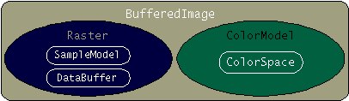
The ColorModel provides a color interpretation of the image's pixel data. The Raster represents the rectangular coordinates of the image, maintains image data in memory, and provides a mechanism for creating multiple subimages from a single image data buffer. The Raster also provides methods for accessing specific pixels within the image. For information about directly manipulating pixel data and writing filters for BufferedImage objects, see the chapter Imaging in the Java 2D Programmer's Guide

Filtering a BufferedImage
The Java 2D API defines several filtering operations for BufferedImage objects. Each image-processing operation is embodied in a class that implements the BufferedImageOp interface. The image manipulation is performed in the image operation's filter method. The BufferedImageOp classes in the Java 2D API support
- Affine transformation
- Amplitude scaling
- Lookup-table modification
- Linear combination of bands
- Color conversion
- Convolution
To filter a BufferedImage using one of the image operation classes, you
- Construct an instance of one of the BufferedImageOp classes: AffineTransformOp, BandCombineOp, ColorConvertOp, ConvolveOp, LookupOp, or RescaleOp.
- Call the image operation's filter method, passing in the BufferedImage that you want to filter and the BufferedImage where you want to store the results.

Example: ImageOps
The following applet illustrates the use of four image-filter operations: low-pass, sharpen, lookup, and rescale.
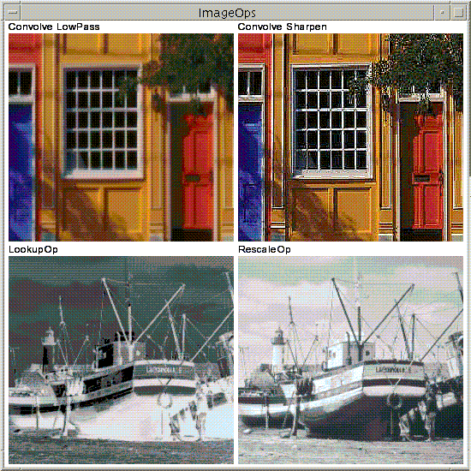
This is a picture of the applet's GUI. To run the applet, click the picture. The applet will appear in a new browser window.
You can see the complete code for this applet in ImageOps.java. The applet uses these two image files: bld.jpg and boat.gif.
The sharpen filter is performed by using a ConvolveOp. Convolution is the process of weighting or averaging the value of each pixel in an image with the values of neighboring pixels. Most spatial-filtering algorithms are based on convolution operations.
To construct and apply the sharpen filter to the BufferedImage, this sample uses code similar to the following snippet.
public static final float[] SHARPEN3x3 = {
0.f, -1.f, 0.f,
-1.f, 5.0f, -1.f,
0.f, -1.f, 0.f};
BufferedImage dstbimg = new
BufferedImage(iw,ih,BufferedImage.TYPE_INT_RGB);
Kernel kernel = new Kernel(3,3,SHARPEN3x3);
ConvolveOp cop = new ConvolveOp(kernel,
ConvolveOp.EDGE_NO_OP,
null);
cop.filter(srcbimg,dstbimg);
The Kernel object mathematically defines how each output pixel is affected by pixels in its immediate area.The definition of the Kernel determines the results of the filter. For more information about how kernels work with ConvolveOp , see the Image Processing and Enhancement section in the Java 2D Programmer's Guide

Using a BufferedImage for Double Buffering
When a graphic is complex or is used repeatedly, you can reduce the time it takes to display it by first rendering it to an off-screen buffer and then copying the buffer to the screen. This technique, called double buffering, is often used for animations.

Note: When you are rendering into a Swing component, Swing automatically double-buffers the display.

A BufferedImage can easily be used as an off-screen buffer. To create a BufferedImage whose color space, depth, and pixel layout exactly match the window into which you're drawing, call the Component createImage method. If you need control over the off-screen image's type or transparency, you can construct a BufferedImage object directly and use it as an off-screen buffer.
To draw into the buffered image, you call the BufferedImage createGraphics method to get a Graphics2D object; then you call the appropriate rendering methods on the Graphics2D. All of the Java 2D API rendering features can be used when you're rendering to a BufferedImage that's being used as an off-screen buffer.
When you're ready to copy the BufferedImage to the screen, you simply call drawImage on your component's Graphics2D and pass in the BufferedImage.

Example: BufferedShapeMover
The following applet allows the user to drag a rectangle around within the applet window. Instead of rendering the rectangle at every mouse location to provide feedback as the user drags it, a BufferedImage is used as an off-screen buffer. As the rectangle is dragged, it is re-rendered into the BufferedImage at each new location and the BufferedImage is blitted to the screen.
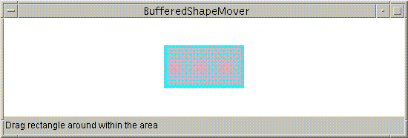
This is a picture of the applet's GUI. To run the applet, click the picture. The applet will appear in a new browser window.
The source code for the applet is in BufferedShapeMover.java.
Here is the code used to render into the BufferedImage and display the image on the screen:
public void updateLocation(MouseEvent e){
rect.setLocation(last_x + e.getX(),
last_y + e.getY());
...
repaint();
...
// In the update method...
if(firstTime) {
Dimension dim = getSize();
int w = dim.width;
int h = dim.height;
area = new Rectangle(dim);
bi = (BufferedImage)createImage(w, h);
big = bi.createGraphics();
rect.setLocation(w/2-50, h/2-25);
big.setStroke(new BasicStroke(8.0f));
firstTime = false;
}

// Clears the rectangle that was previously drawn.
big.setColor(Color.white);
big.clearRect(0, 0, area.width, area.height);

// Draws and fills the newly positioned rectangle
// to the buffer.
big.setPaint(strokePolka);
big.draw(rect);
big.setPaint(fillPolka);
big.fill(rect);

// Draws the buffered image to the screen.
g2.drawImage(bi, 0, 0, this);
}

